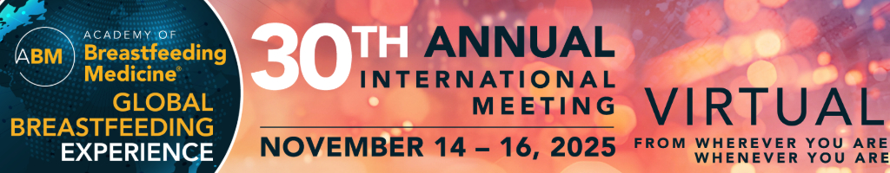
ABM 30th Annual International Meeting Watch Party Social Media Posts
Social posts promoting the watch party:
- We’re excited to host a watch party for the ABM 30th Annual International Meeting right here [in/at] [City/Institution]!

We’re gathering locally to watch the sessions live, share ideas, and build new connections while enjoying a 5% discount for everyone who joins our group.

If you’re in the area and want to take part, reach out! We’ll share our special registration code and details on how to join us.

- We're hosting a watch party for the ABM 30th Annual International Meeting!

We’re creating a local space to bring global discussions closer to home—watching sessions, learning about the latest insights in breastfeeding medicine, and engaging in conversations that matter to our practice.

Want to be part of it? Join us and use our registration code for a 5% discount. Send me a message for details—we’d love to have you with us!

- I’m hosting a watch party for the ABM 30th Annual International Meeting!

This is a chance for us to come together locally, even as the sessions stream virtually.

Everyone in our group will get a 5% registration discount—message me for the code and join us!

- I’m joining a watch party for the ABM 30th Annual International Meeting! Excited to watch and discuss with colleagues nearby. If you’re interested in joining and saving 5% on registration, send me a message!

- I’m joining a watch party for the ABM 30th Annual International Meeting, tuning in with others from our area. Let me know if you’d like to join our group and save 5% on registration!

- Excited to be part of a watch party for the ABM 30th Annual International Meeting! We’re bringing this year’s virtual meeting to [City/Institution]. Message me if you’d like to join the fun and save 5% on registration!

Social posts during the watch party (post with photos of your group!):
- Tuning into the ABM 30th Annual International Meeting together at our watch party! So many great insights coming out of this year’s meeting—glad to be sharing them live with this group.
- Our watch party is in full swing! Loving the chance to watch, learn, and chat with colleagues during this year’s virtual meeting.
- Tuning in for Day [#] of the ABM 30th Annual International Meeting at our watch party—lots of great conversations and insights!

Hashtags: #ABM2025 #ABMWatchParty #ABMAnnualInternationalMeeting #Celebrating30Years #2025GlobalBreastfeedingExperience

