1. Click on UCLan-Open in your Wi-Fi settings to connect to the UCLan-Open Wireless network
Examples –
Apple iPhone Windows 7
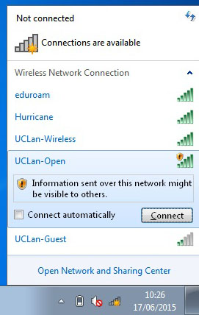
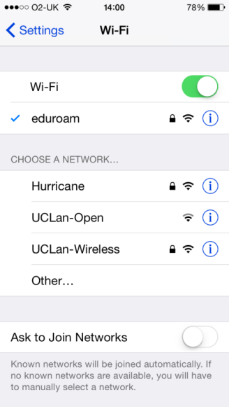
2. Open a web browser and browse to any page to bring up the Login page (some devices may automatically display a web browser or ask you to click to display one in order to authenticate). Enter your email address and click the Accept button if you agree to the UCLan Terms of Use shown.
Examples –
Apple iPhone Windows
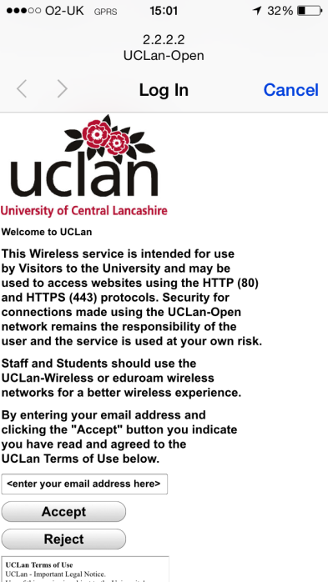
Notes:
- Some devices may say invalid certificate or complain about not being secure, you need to accept these warnings to connect to the UCLan-Open wireless network

- You can use services that work in a web browser and use HTTP or HTTPS protocols. You can also use email.

- Devices occasionally kick you out of the authentication screen before you have finished typing or reading them, just connect again

- Depending on your device you may need to authenticate each time you use the UCLan-Open wireless network (some devices disconnect completely when they go into standby or sleep mode and lose their authentication)

- Some mobile devices automatically display a (limited function) web browser for you to authenticate in. Once you have authenticated, the web browser will jump to a UCLan welcome page. For a subsequent fuller web experience the user should exit out of this browser and start their normal one.

